What is Dementia?
- Dementia is a collective term used to describe the symptoms that individuals with different brain disorders/ damage can have with their memory, language, and thinking.
- Alzheimer’s Disease is the most common/ Known disorder under the Dementia umbrella.

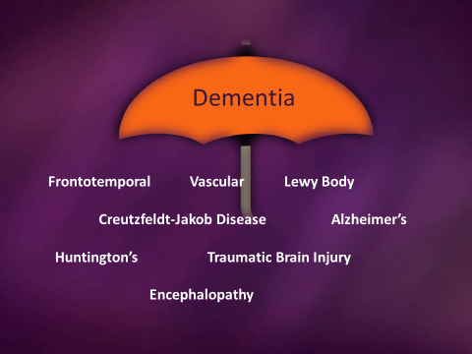

What are some potential signs of Dementia?
- Memory Loss
- Confusion/ Disorientation to Time & Place
- Poor Reasoning/ Impaired Judgment
- Inappropriate Behavior
- Loss of Communication Skills

How do I communicate with/ help someone who has, or may show signs of Dementia?
- Use short, simple sentences
- Allow the person time to process what you are saying
- Address the person by their preferred name

- Let the person know that you are here to help
- Talk slowly and clearly
- Ask one question at a time
- Speak only when you are visible to the person; maintain eye contact
- Limit distractions i.e. hand gestures, noise

What should I NOT DO when communicating with someone who has, or may show signs of Dementia?
- Talk loudly if they do not understand
- Talk as if the person isn’t there
- Look frustrated or mad
- Use sarcasm or humor
- Rush the person
- Argue
  - Who do I call for help?
- In case of Emergency call 911
- The person’s Caregiver (If Possible)
- Police/ Fire Department (within city limits) (865)215-4010
- Rural Metro (outside city limits)
(865)546-9960
  - Who do I contact for more information?
- Purple Cities Alliance www.purplecities.org
- Alzheimer’s Tennessee www.alzTennessee.org (865)544-6288 or toll- free 888-326-9888
- Alzheimer’s Association Eastern TN Chapter www.alz.org/tn (865)200-6668 or 24/7 help line: 1(800)272-3900

